Helmholtz coil solutions

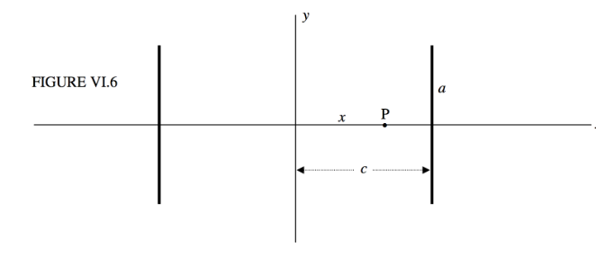When assuming the origin to be center between the coils

$$B=\frac{μNIa^{2}}{{\left(a^{2}+c^{2}\right)}^{\frac{3}{2}}}$$

$$B=magnetic field strength$$ $$μ=1$$ $$N=number of coils$$ $$I = amps$$ $$a = radius of coils$$ $$c = \frac{1}{2}dis\tan{c}e between coils$$

a=27 in =

c= 12 in /2

$$φ = BA$$ $$A = Arenotmy Field$$

$$ε=φ∆t$$ $$ε=Emf$$ $$t=time$$

Other helpful equations

Finding the number of coils

$$N = \frac{A}{a_{d}}$$ $$A = Area of coil$$ $$a_{d}=area of wire = 4πr^{2}$$

Wire ½ mm radius

make the magnetic field 10x earths to determine the effiicany of the magnetorquers

1. 1 u frame with constant density
2. 1 u frame with inconsistent density
3. 2 u frame
4. CS2 test